Using Haplotype Blocks to Map Human Complex Trait Loci
Lon R. Cardon and Goncalo R. Abecasis
Trends in Genetics Vol. 19 No. 3 March 2003
Abstract
The HapMap project held by NIH has been carrying on since 2002 Oct. We are interested in the difference in our genome and how it effect to ourselves.
- Glossary
Linkage Disequilibrium (LD): The non-random association of alleles at tightly linked markers. When LD is very high, alleles of linked markers can sometimes be used as surrogated for the state of nearby loci.

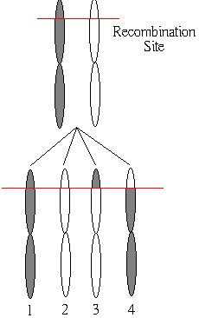

Punctate Recombination: An hypothesized distribution of re- combination events characterized by short, precisely localized sites of recurring recombination and long intervening stretched where recombination is rare.
- Haplotype Blocks
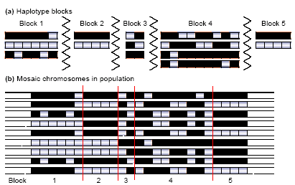
High pair-wise LD
↑
↓
Low haplotype diversity

Most studies used in silico block definitions that infer block structure and boundaries. Block is usually defined when a small number of haplotypes (e.g. 3~5) account for a high proportion of the observations (75%~90%).
Whenever the pair-wise measure or haplotypes are used, population and sample comparisons of block distribution are especially difficult.
Although superficially distinct, measures based on the two methods are highly correlated: low haplotype diversity exhibits high pair-wise LD.
- Blocks Everywhere?
Block-like patterns have been observed in the immunoglobulin cluster on 5q31, within HLA and throughout chromosomes 21 and 22. These blocks were flanked by precisely localized recombination hotspots, leading to suggestions that punctate recombination could be a general phenomenon underlying block structure.
- SNP Density
Genotyping budgets and technology place practical limitations on large-scale studies. Studies using denser marker panel have identified more short blocks, whereas studies using sparser marker panels have identified longer blocks.
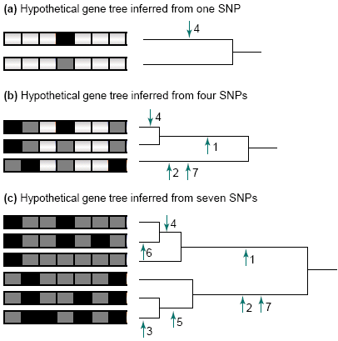
- Conclusion
Created by: Chia-Ling Sun
Date: Nov. 14, 2003

